WORD 101 – Insert a Shape

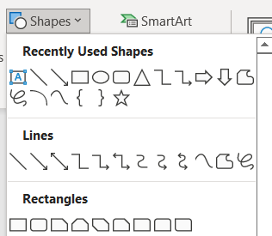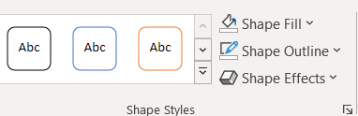
Using the shapes tool (from the “Insert” tab), draw the correct shape below.
This is done by click/hold and drag the “+sign” to the size you’d like.
Change the outline and fill using the toolbar in the Shapes Format Tab.
This will have to be done using the DESKTOP version. Click on the “Editing” drop down menu -> Open in Desktop App.
Red and Blue Square | Yellow and Orange Star | Purple and Orange Rectangle
Blue and Yellow Arrow | Orange and Red Banner | Purple and Yellow Callout
Red and Purple Rectangle | Light Blue and Light Green Square | Orange and Red Oval
Yellow and Purple Circle | Red and Red Heart | Blue and Green Plus Sign

