WORD 101 – FORMAT THE TEXT
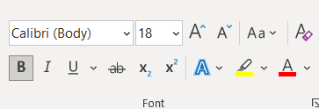
Using the font toolbar, highlight each word and change it according to legend below.
Cooper Black 10 Orange
Comic Sans 18 Blue
Calibri 12 Red

Magneto 11 Green
Berlin Sans FB 10 Yellow

Showcard Gothic 8 Light Green
Times New Roman 12 Red
Palatino Linotype 10 Purple
Snap ITC 10 Orange
Calibri 11 Light Blue
Daytona 16 Red
Abadi 18 Purple

