Toy Name | Picture | Price
Mini Bouncing Balls  (Pack of 6) | 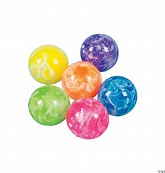 | $4
Plastic Dinosaurs  (Set of 5) | 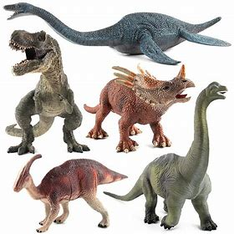 | $5
Yo-Yo  (Assorted Colors) | 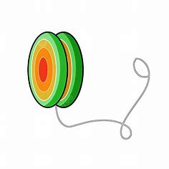 | $2
Jumping Frogs  (Pack of 12) | 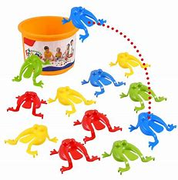 | $3
Sticky Hands  (Set of 4) | 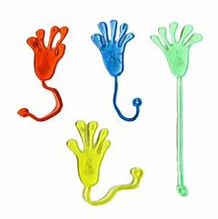 | $4
Mini Construction Vehicles  (Set of 5) | 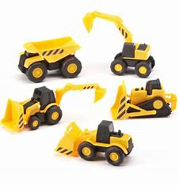 | $5
Squishy Toy Pack (12 Pieces) | 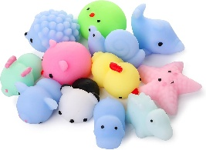 | $6
Water Marbles (1 Liter) | 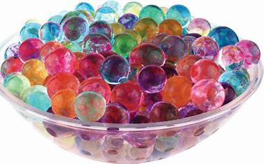 | $3
Minifigures (Each) | 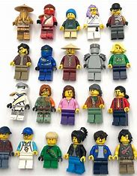 | $3
Stretch & Bounce Ball | 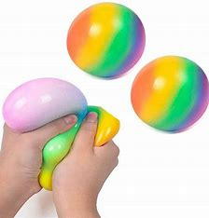 | $2

What could you buy with $10?

What could you buy with $20?

Canadian Currency (dollars) spinner
Use a pencil and a paper clip to make a spinner.
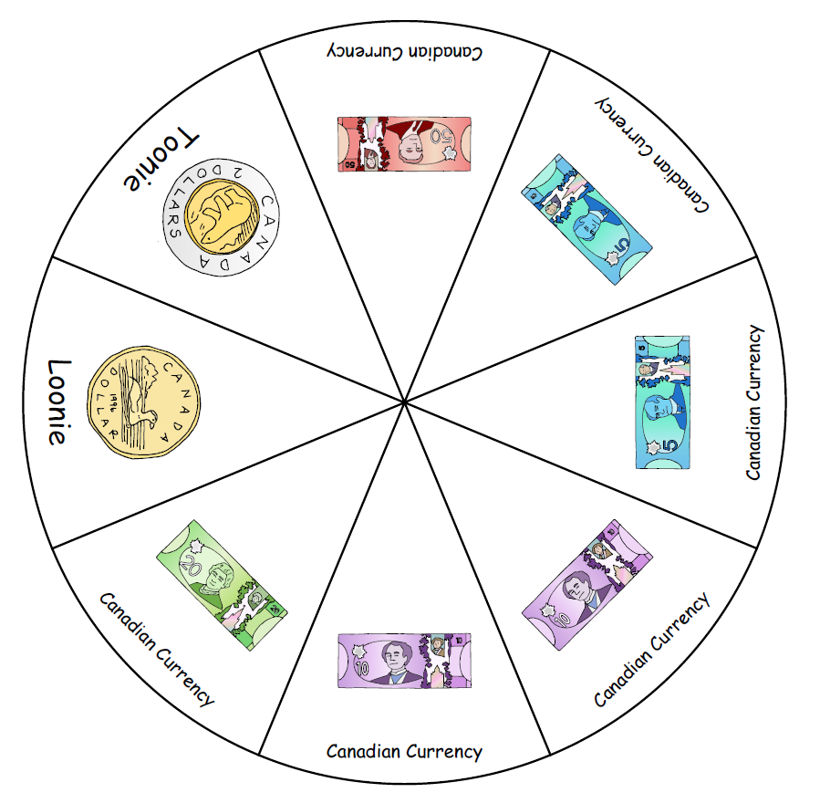

Design your own coin
FRONT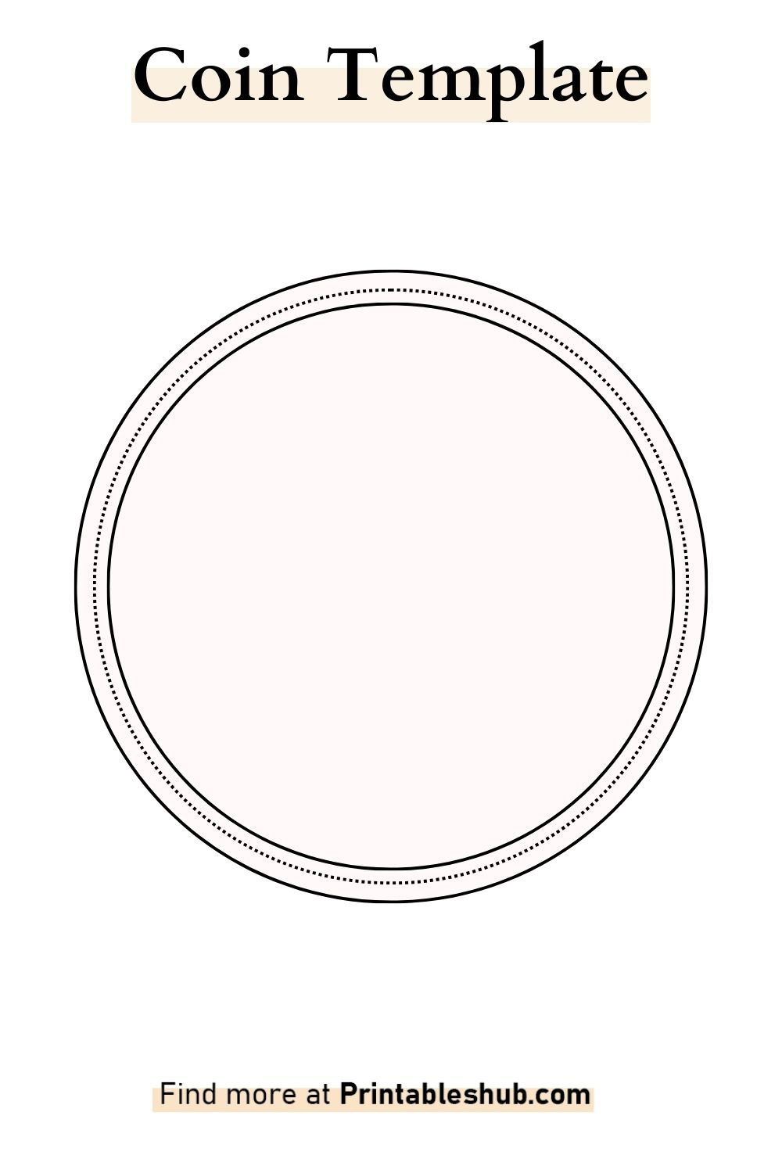
BACK

Canada’s vertical $10 note - Bank of Canada

Canada 150 commemorative $10 note - Bank of Canada

