Regional Seasonal Round
Seasonal Biodiversity Waypoints
- Ducks and geese nesting
- Frogs emerge
- Herring spawn
- Return of eulachon fish
- Skunk cabbage blooms
- Beavers rebuild dams after spring rains
- Garter snakes hatch
- Bees emerge looking for nectar
- Butterflies hatch
- Flowers start blooming, pollen is plentiful
- Spring salmon return
- Dragon flies hatch
- Crabs hatch
- Huckle berries ripen
- Salmonberries & trailing blackberries ripen
- Oregon grape and salal berries ripen
- Humpback whale return to hunt
- Otter pups are born
- Bats migrate north to hibernaculum (preparing for winter)
- Mushroom picking
- Clams are safe for people to eat
- Orcas feed on returning salmon
- Coho, chum, and pink salmon return to spawn
- Bears, eagles, and wolves hunt returning salmon
- Owls, woodpeckers, and other winter birds can be spotted
- Winter storms blow down trees and scatter cones
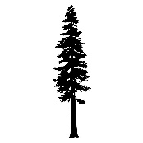
Campbell River Area
AUTUMN
SUMMER
SPRING
WINTER
WEST
EAST
SOUTH
NORTH
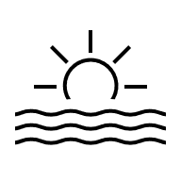

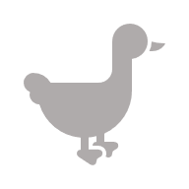
ENERGY
SKY
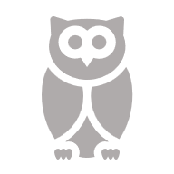
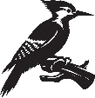
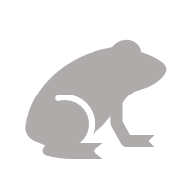
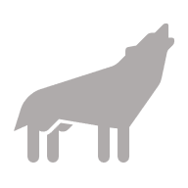

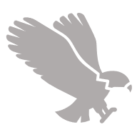
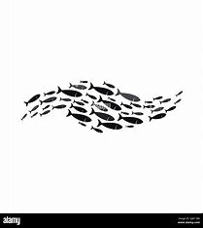
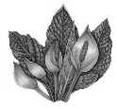
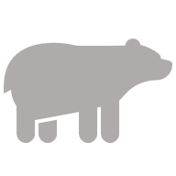
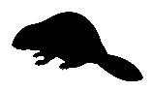
Winter Solstice
Spring Equinox

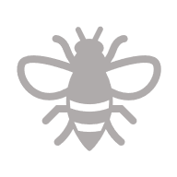

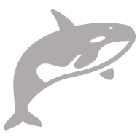

Autumn Equinox
Summer Solstice
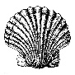
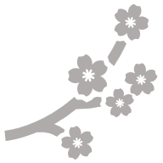


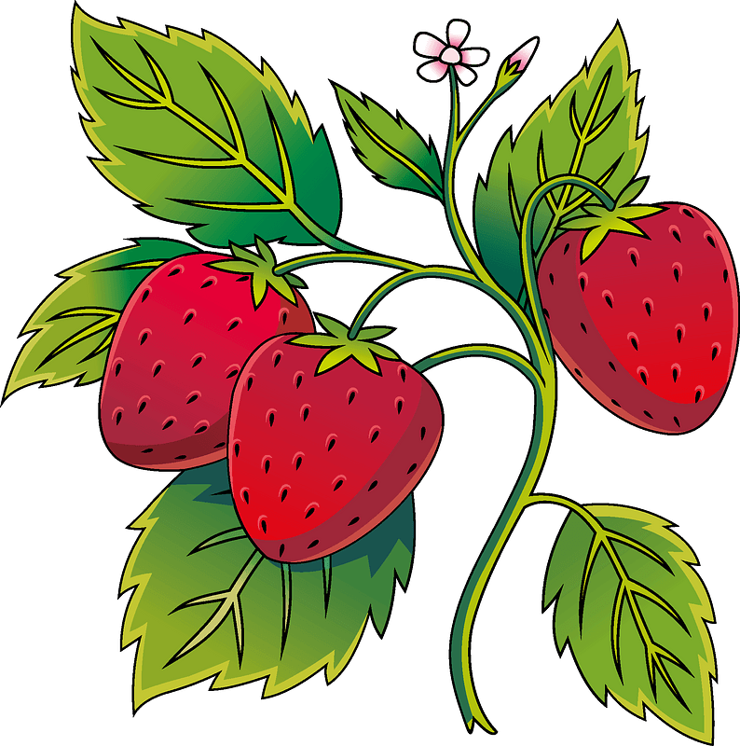
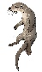
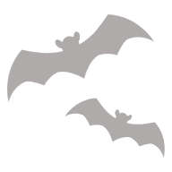

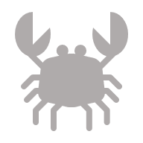
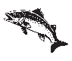
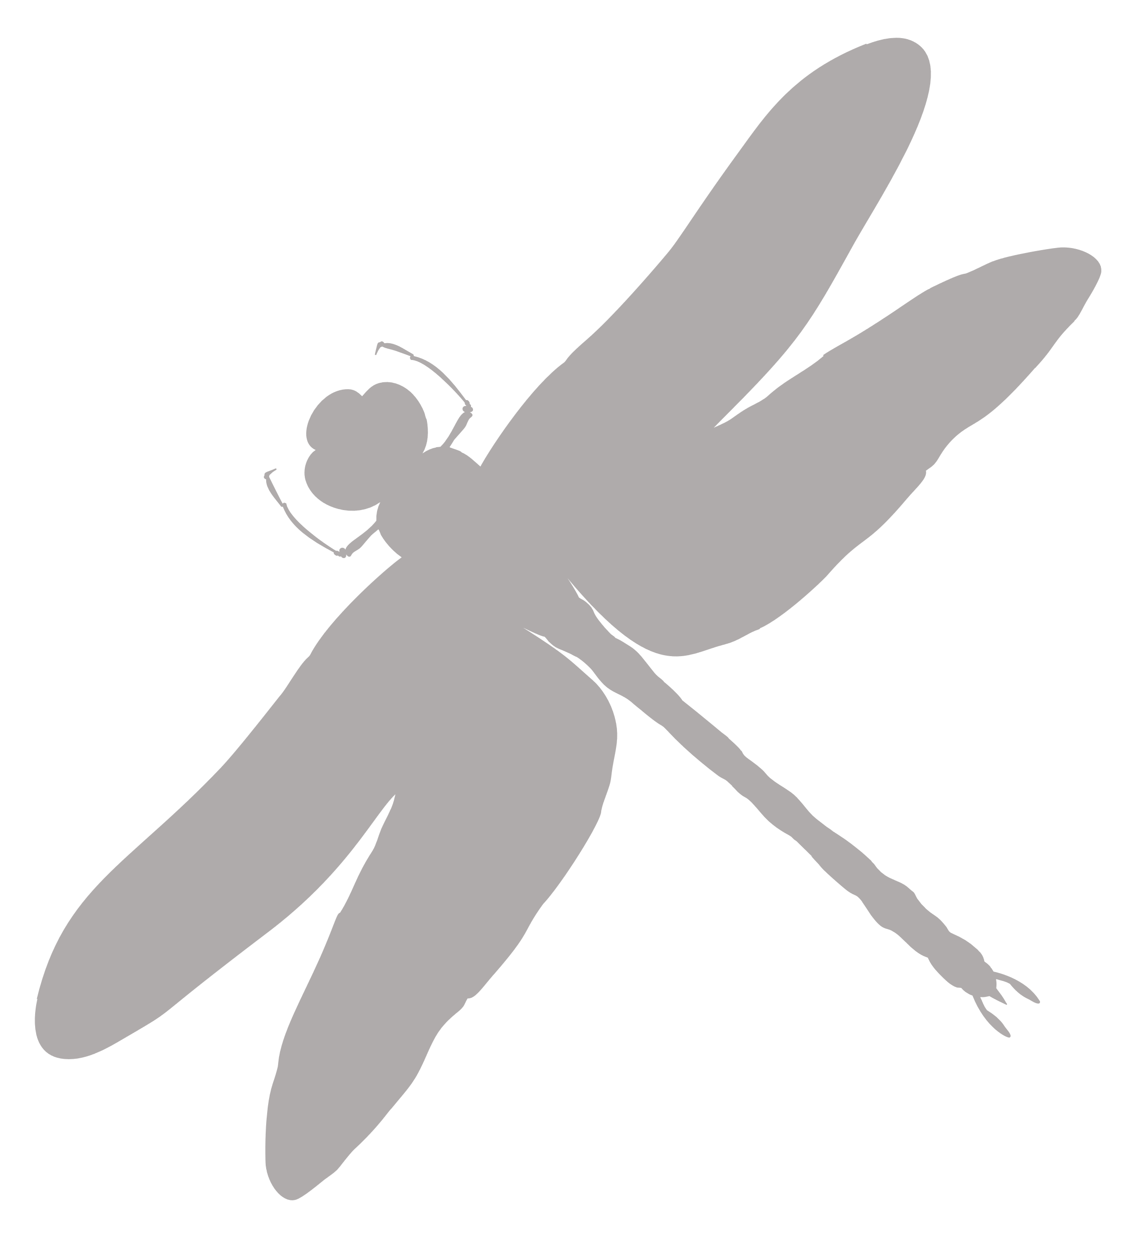
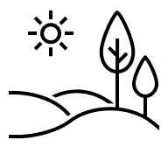
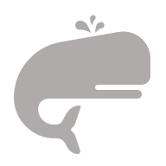
SEA
EARTH

Moon Phase Calendar 2026
