1 | 2 | 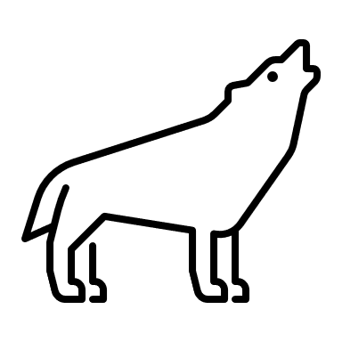 | 4 | 5 | 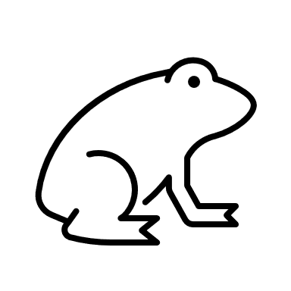 | 7 | 8 | 9
11 | 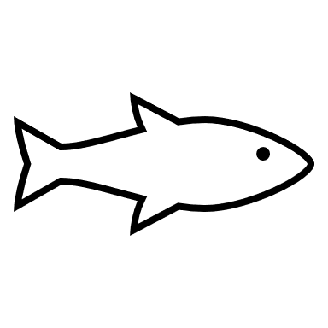 | 13 | 14 | 15 | 16 | 17 | 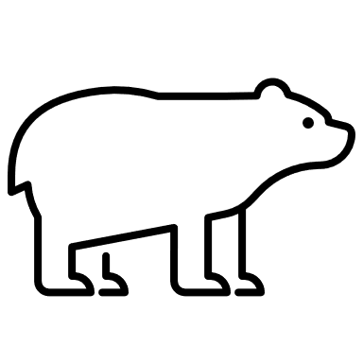 | 19 | 20
21 | 22 | 23 |  | 25 | 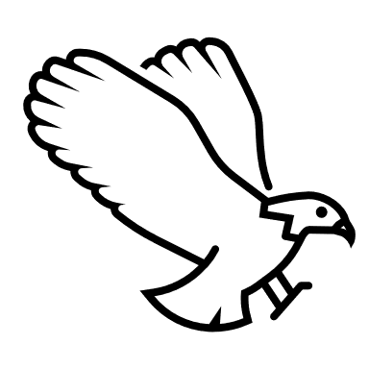 | 27 | 28 | 29 | 30
31 | 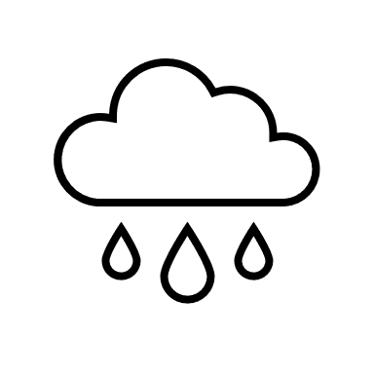 | 33 | 34 | 35 | 36 | 37 |  | 39 | 40
41 | 42 | 43 |  | 45 | 46 | 47 | 48 | 49
 | 52 | 53 | 54 | 55 | 56 |  | 58 | 59 | 60
61 | 62 |  | 64 | 65 | 66 | 67 | 68 |  | 70
 | 72 | 73 | 74 | 75 |  | 77 | 78 | 79 | 80
81 | 82 | 83 |  | 85 | 86 | 87 |  | 89
91 |  | 93 | 94 | 95 |  | 97 | 98 | 99 | 100
 | 102 |  | 104 | 105 | 106 |  | 108 |  | 110

Directions
Set the Race to 110 Chart on a table or floor.
Roll the die and move that number of spaces with your counter.
If you land on a Pacific Northwest symbol, follow the directions given below.
Play continues until one player lands on or passes the 110 space.
Have fun racing to 110!

Bear in the area! Move back 10 spaces
Run with the pack. Move ahead 1 space
Rainstorm! Change your coat. Move back 1 space
Take a break to go fishing (Wait one turn)
Fly ahead 10 spaces
Ribbit, ribbit, roll again!

