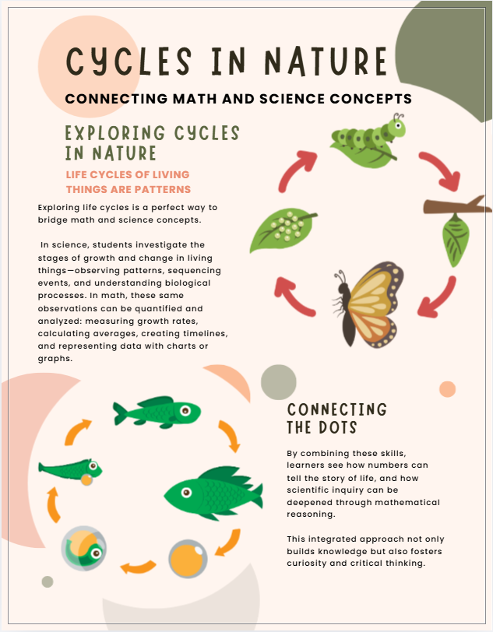
🐸 Life Cycle of a Frog – Lesson Summary
🎯 Learning Goals
Students will:
- Identify the four stages of a frog’s life cycle
- Describe how frogs change at each stage
- Put the stages in the correct order
- Understand that frogs undergo metamorphosis (major body changes)
🧠 Key Vocabulary
Life cycle, egg, tadpole, froglet, adult frog, metamorphosis
🐸 Frog Life Cycle Stages
- Egg – Frogs lay eggs in water, often in clusters called frogspawn.
- Tadpole – Tadpoles hatch from eggs, live in water, have tails and gills, and no legs.
- Froglet – Tadpoles grow legs, develop lungs, and their tails shrink.
- Adult Frog – Fully grown frogs have no tail, live on land and in water, and can lay eggs.
🚀 Lesson Activities
- Introduction: Discuss what students already know about frogs; show a picture or video.
- Teaching: Explain each life cycle stage using visuals or a diagram.
- Guided Practice: Students sequence pictures of the frog life cycle.
- Independent Work: Students complete a worksheet, draw the stages, or make a simple craft.
✅ Assessment
- Students explain one stage of the life cycle
- Simple drawing or labeling activity to check understanding
🔄 Closure
Review the stages and reinforce that frogs change throughout their lives. Emphasize the term metamorphosis.
🌟 Extensions & Supports
- Compare frog life cycle with other animals (e.g., butterflies)

🦋 Life Cycle of a Butterfly – Lesson Summary
🎯 Learning Goals
Students will:
  - Identify the four stages of a butterfly’s life cycle
  - Describe the changes at each stage
  - Sequence the stages correctly
  - Understand that butterflies undergo metamorphosis
🧠 Key Vocabulary
Life cycle, egg, larva (caterpillar), pupa (chrysalis), adult butterfly, metamorphosis
🦋 Butterfly Life Cycle Stages
- Egg – Butterflies lay tiny eggs on leaves.
- Larva (Caterpillar) – The egg hatches into a caterpillar that eats leaves and grows quickly.
- Pupa (Chrysalis) – The caterpillar forms a chrysalis where it changes inside.
- Adult Butterfly – A fully formed butterfly emerges, flies, and lays eggs to start the cycle again.
🚀 Lesson Activities
  - Introduction: Ask students what they know about butterflies; show pictures or a short video.
  - Teaching: Explain each stage using visuals or diagrams.
  - Guided Practice: Students arrange pictures of the butterfly life cycle in order.
  - Independent Work: Students complete a worksheet, draw the stages, or create a simple craft.
✅ Assessment
  - Students describe or name one stage of the life cycle
  - Drawing or labeling activity to demonstrate understanding
🔄 Closure
Review the stages and emphasize that butterflies change dramatically during their life cycle. Reinforce the idea of metamorphosis.
🌟 Extensions & Supports
- Compare butterfly and frog life cycles

🌱 Life Cycle of a Bean Plant – Lesson Summary
🎯 Learning Goals
Students will:
- Identify the stages of a bean plant’s life cycle
- Describe how the plant changes at each stage
- Sequence the stages correctly
- Understand what plants need to grow (water, sunlight, soil)
🧠 Key Vocabulary
Life cycle, seed, germination, seedling, plant, roots, stem, leaves
🌱 Bean Plant Life Cycle Stages
- Seed – The life cycle begins with a bean seed planted in soil.
- Germination – The seed absorbs water, swells, and begins to sprout roots and a small shoot.
- Seedling – A young plant emerges above the soil with small leaves and a growing stem.
- Developing Plant – The plant grows larger, develops more leaves
- Mature Bean Plant - The plant produces flowers and beans (seeds).
🚀 Lesson Activities
- Introduction: Ask students what plants need to grow; show a real seed or picture.
- Teaching: Explain each stage with visuals or a diagram.
- Guided Practice: Students sequence pictures of the plant life cycle.
- Independent Work: Students complete a worksheet, draw the stages, or plant a bean seed.
✅ Assessment
- Students describe one stage of the plant’s growth
- Drawing or labeling activity to check understanding
🔄 Closure
Review the stages and discuss how plants grow over time. Reinforce that all living things have life cycles.
🌟 Extensions & Supports
- Grow beans in the classroom and observe changes daily
- Compare plant life cycles with animals
🐞 Life Cycle of a Ladybug – Lesson Summary
🎯 Learning Goals
Students will:
- Identify the four stages of a ladybug’s life cycle
- Describe the changes at each stage
- Sequence the stages correctly
- Understand that ladybugs undergo metamorphosis
🧠 Key Vocabulary
Life cycle, egg, larva, pupa, adult ladybug, metamorphosis
🐞 Ladybug Life Cycle Stages
- Egg – Ladybugs lay tiny yellow eggs on leaves, often near aphids (their food).
- Larva – The eggs hatch into larvae that look long and spiky; they eat lots of insects and grow quickly.
- Pupa – The larva attaches to a surface and forms a pupa, where it changes inside.
- Adult Ladybug – A fully formed ladybug emerges with wings and spots, ready to eat and lay eggs.
🚀 Lesson Activities
- Introduction: Ask students what they know about ladybugs; show pictures or a short video.
- Teaching: Explain each stage using visuals or a diagram.
- Guided Practice: Students arrange pictures of the life cycle in order.
- Independent Work: Students complete a worksheet, draw the stages, or create a simple craft.
✅ Assessment
- Students explain or name one stage of the life cycle
- Drawing or labeling activity to show understanding
🔄 Closure
Review the stages and emphasize that ladybugs change a lot as they grow. Reinforce the concept of metamorphosis.
🌟 Extensions & Supports
- Compare ladybug and butterfly life cycles
- Use visuals and labels to support learning
- Have advanced students write sentences about each stage

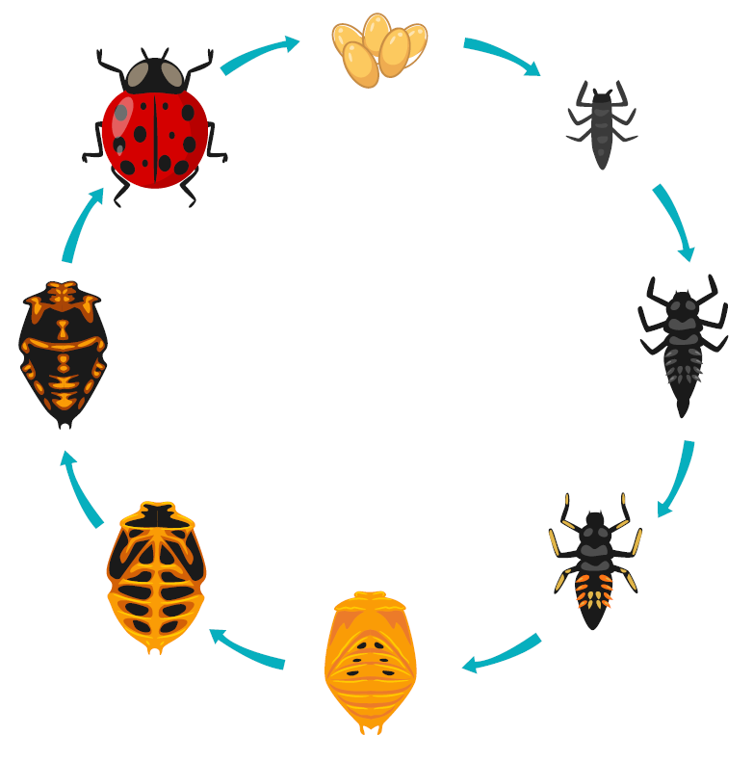

🐔 Life Cycle of a Chicken – Lesson Summary
🎯 Learning Goals
Students will:
- Identify the stages of a chicken’s life cycle
- Describe changes at each stage
- Sequence the stages in order
- Learn vocabulary for male and female chickens
🧠 Key Vocabulary
Life cycle, egg, chick, adult
Hen (female chicken), Rooster (male chicken)
🐔 Chicken Life Cycle Stages
- Egg – The life cycle begins inside an egg laid by a hen. The chick develops inside the egg.
- Chick – A baby chicken hatches from the egg. Chicks are small, soft, and covered with down feathers.
- Growing Chicken (Juvenile) – The chick grows larger, develops feathers, and becomes stronger.
- Adult Chicken – A fully grown chicken.
  - A female is called a hen
  - A male is called a rooster
Adult chickens can reproduce, and hens lay eggs to begin the cycle again.
🚀 Lesson Activities
- Introduction: Ask students if they have seen chickens or eggs; show pictures or a short video.
- Teaching: Explain each stage using visuals or diagrams.
- Guided Practice: Students arrange life cycle pictures in the correct order.
🔄 Closure
Review the stages and reinforce that chickens grow and change over time.
🌟 Extensions & Supports
- Compare chicken life cycle with other birds, frogs or butterflies
- Use real or toy models for hands-on learning
- Have advanced students write sentences about each stage

🐝 Life Cycle of a Bee – Lesson Summary
🎯 Learning Goals
Students will:
- Identify the four stages of a bee’s life cycle
- Describe how bees change at each stage
- Sequence the stages correctly
- Understand basic roles of bees in a colony
🧠 Key Vocabulary
Life cycle, egg, larva, pupa, adult bee
Queen bee, worker bee, drone
🐝 Bee Life Cycle Stages
- Egg – The queen bee lays tiny eggs inside honeycomb cells.
- Larva – The egg hatches into a worm-like larva that is fed by worker bees and grows quickly.
- Pupa – The larva forms a pupa inside the cell, where it changes into an adult bee.
- Adult Bee – A fully grown bee emerges. There are different types of adult bees:
  - Queen bee – lays eggs
  - Worker bees (female) – gather food and care for the hive
  - Drones (male) – help with reproduction
🚀 Lesson Activities
- Introduction: Ask students what they know about bees; show pictures or a short video.
- Teaching: Explain each stage using visuals or diagrams.
- Guided Practice: Students arrange the life cycle stages in order.
- Independent Work: Students complete a worksheet, draw the stages, or create a bee life cycle craft.
🔄 Closure
Review the stages and explain how bees grow and work together in a hive.
🌟 Extensions & Supports
- Compare bee life cycle with butterfly or ladybug
- Discuss why bees are important (pollination)

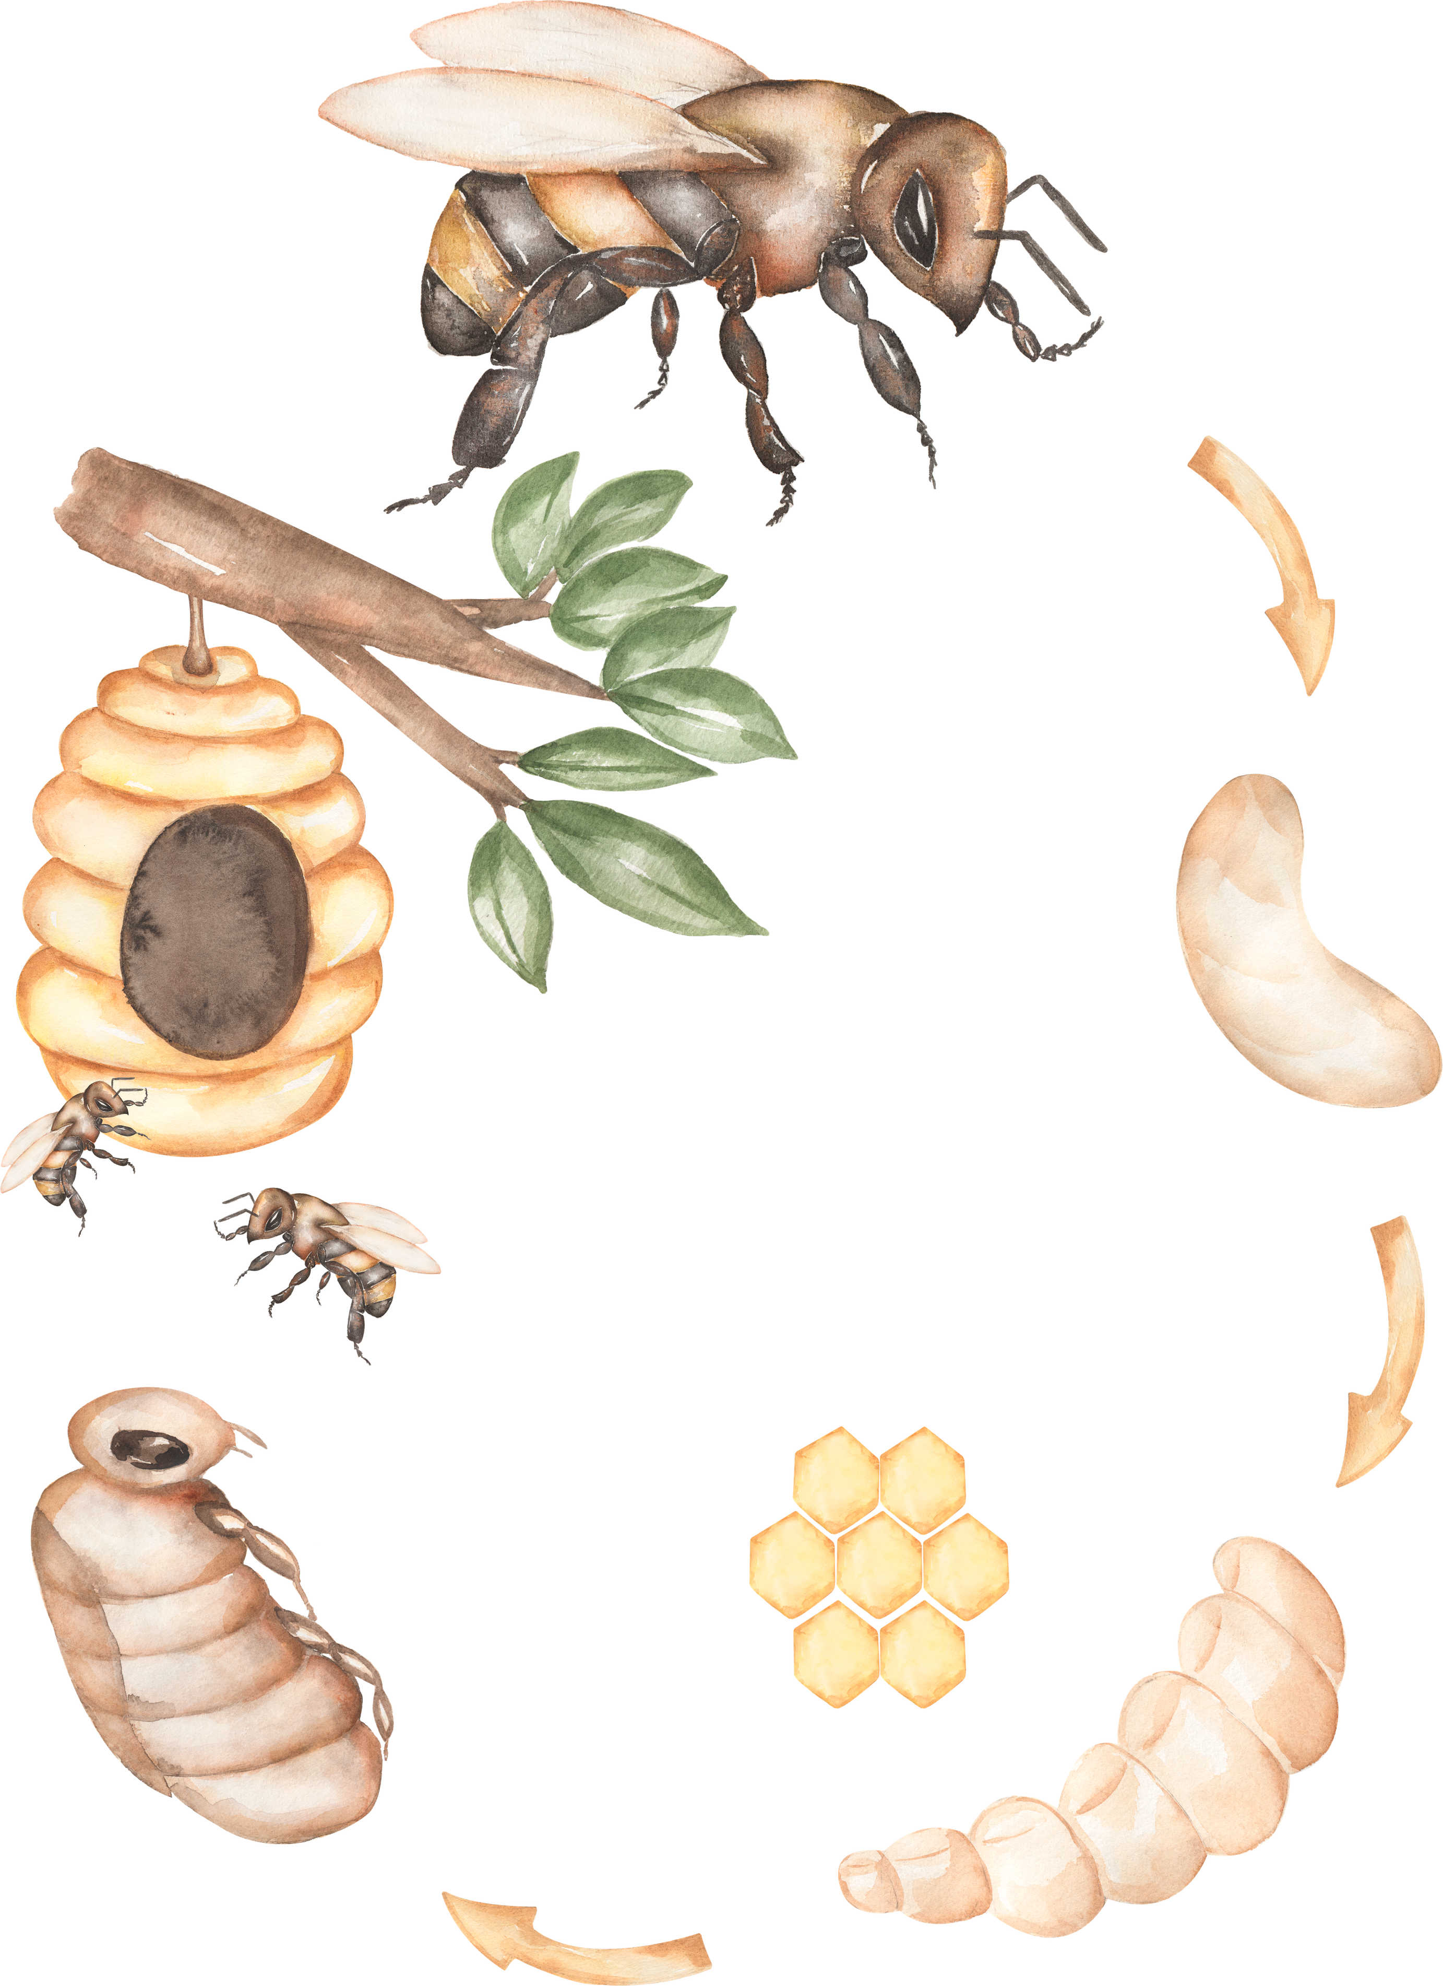
🐙 Life Cycle of an Octopus – Lesson Summary
🎯 Learning Goals
Students will:
- Identify the stages of an octopus’s life cycle
- Describe how octopuses change as they grow
- Sequence the stages correctly
🧠 Key Vocabulary: Life cycle, egg, larva, juvenile, adult octopus, hatchling
🐙 Octopus Life Cycle Stages
- Egg – Eggs are laid by the female octopus and attached in clusters to rocks or surfaces. The mother protects and cares for them until they hatch.
- Larva (Hatchling) – Tiny octopuses hatch from the eggs and float in the water. They are very small and drift in the ocean currents.
- Juvenile Octopus – As they grow, they begin to settle near the ocean floor, hunt food, and develop stronger bodies.
- Adult Octopus – A fully grown octopus lives on the ocean floor, hunts for food, and can reproduce to start the life cycle again.
🚀 Lesson Activities
- Introduction: Ask students what they know about octopuses; show pictures or a short video.
- Teaching: Explain each stage using visuals or diagrams.
- Guided Practice: Students arrange the life cycle stages in order.
- Independent Work: Students draw the stages, label them, or complete a worksheet.
✅ Assessment
- Students name or describe one stage of the life cycle
- Drawing or labeling activity to show understanding
🔄 Closure
Review the stages and discuss how octopuses grow in the ocean. Reinforce that all animals have life cycles.
🌟 Extensions & Supports
- Compare octopus life cycle with land animals or insects
- Discuss ocean habitats and animal survival

🌿 Life Cycle of a Fern – Lesson Summary
🎯 Learning Goals
Students will:
- Identify the stages of a fern’s life cycle
- Describe how ferns grow and change
- Sequence the stages in order
- Understand that some plants reproduce using spores instead of seeds
🧠 Key Vocabulary
Life cycle, spores, germination, gametophyte, fern plant, frond
🌿 Fern Life Cycle Stages
- Spores – Ferns release tiny spores (like dust) from the underside of their leaves (called fronds).
- Germination – When spores land in a moist place, they begin to grow into a tiny, flat plant.
- Gametophyte (Young Plant Stage) – This small plant produces the cells needed to grow a new fern.
- Adult Fern – A full-grown fern develops with roots and fronds and produces spores, starting the cycle again.
🚀 Lesson Activities
- Introduction: Ask students if they have seen ferns; show real plants or pictures.
- Teaching: Explain each stage with diagrams or visuals.
- Guided Practice: Students sequence the life cycle stages in order.
- Independent Work: Students draw and label the stages or complete a worksheet.
✅ Assessment
- Students name or describe one stage
- Drawing or labeling activity to demonstrate understanding
🔄 Closure
Review how ferns grow and emphasize that, unlike many plants, ferns do not use seeds but reproduce with spores.
🌟 Extensions & Supports
- Compare fern life cycle with flowering plants (seed vs. spore)
- Go on a nature walk to find ferns
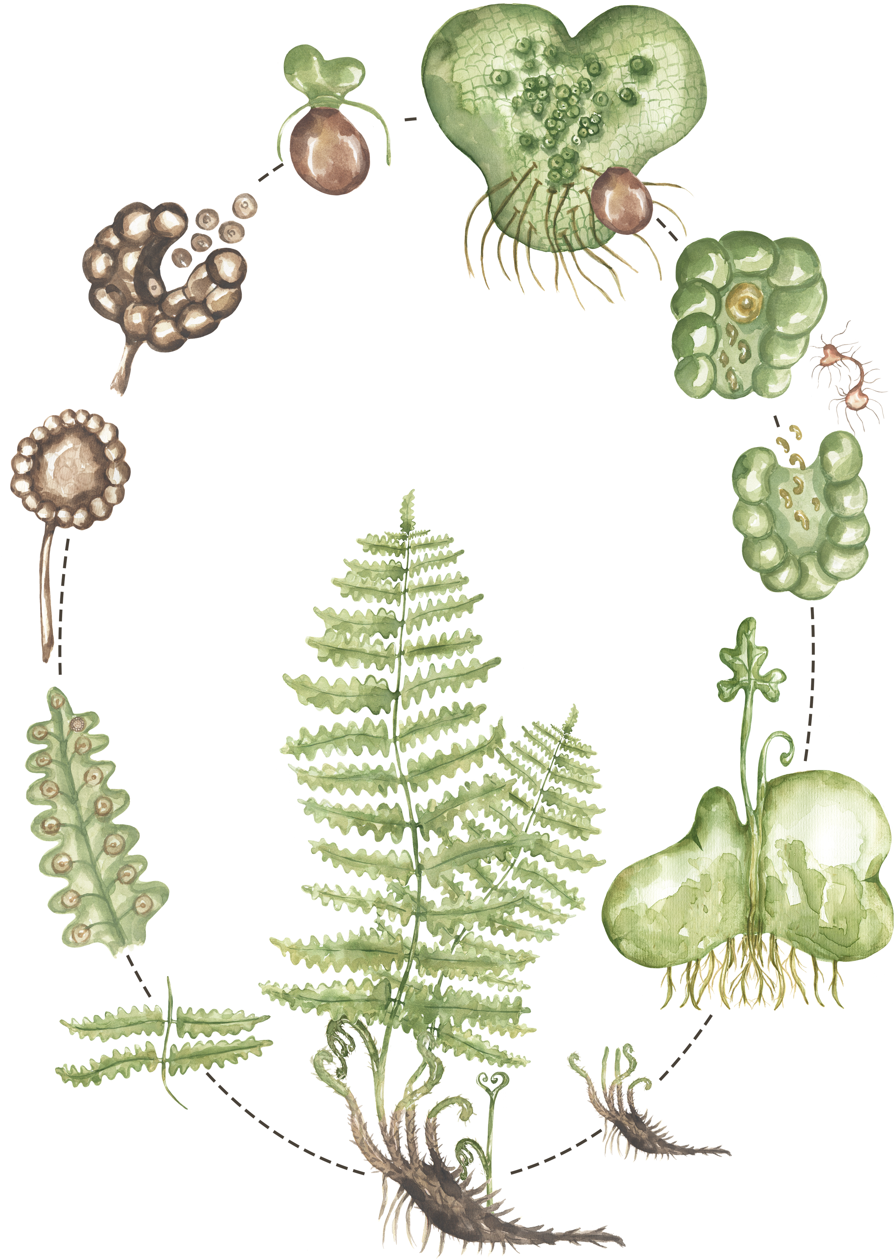
🦀 Life Cycle of a Crab – Lesson Summary
🎯 Learning Goals
Students will:
- Identify the stages of a crab’s life cycle
- Describe how crabs change as they grow
- Sequence the stages correctly
- Understand that crabs grow by molting (shedding their shell)
🧠 Key Vocabulary: Life cycle, egg, larva, juvenile, adult crab, molt, shell
🦀 Crab Life Cycle Stages
- Egg – Female crabs carry eggs under their bodies until they hatch.
- Larva – Tiny larvae hatch and float in the water. They look very different from adult crabs.
- Juvenile Crab – As they grow, they begin to look more like crabs and move to the ocean floor. They shed their shells (molt) as they grow bigger.
- Adult Crab – A fully grown crab lives on the ocean floor, has a hard shell, and can reproduce to start the life cycle again.
🚀 Lesson Activities
- Introduction: Ask students what they know about crabs; show pictures or a short video.
- Teaching: Explain each stage using visuals or diagrams.
- Guided Practice: Students arrange the life cycle stages in order.
- Independent Work: Students draw, label, or complete a worksheet about the stages.
✅ Assessment
- Students name or describe one stage of the life cycle
- Drawing or labeling activity to show understanding
🔄 Closure
Review the stages and explain how crabs grow by shedding their shells. Reinforce that all animals have life cycles.
🌟 Extensions & Supports
- Compare crab life cycle with other ocean animals
- Discuss ocean habitats and how crabs survive
🍓 Life Cycle of a Strawberry Plant – Lesson Summary
🎯 Learning Goals
Students will:
- Identify the stages of a strawberry plant’s life cycle
- Describe how the plant grows and changes
- Sequence the stages in order
- Understand that strawberry plants can grow from seeds and runners
🧠 Key Vocabulary
Life cycle, seed, germination, seedling, flower, fruit, runner
🍓 Strawberry Plant Life Cycle Stages
- Seed – The life cycle begins with a tiny seed (often found on the outside of the strawberry fruit).
- Germination – The seed begins to grow when it has water, sunlight, and soil, forming roots and a small shoot.
- Seedling/Young Plant – A small plant grows with leaves, roots, and stems.
- Flowering Plant – The plant produces white flowers, which are necessary for fruit to grow.
- Fruit (Strawberry) – The flowers develop into strawberries, which contain seeds and can be eaten.
- Runner (New Plants) – Strawberry plants grow long stems called runners that spread along the ground and grow into new plants.
🚀 Lesson Activities
- Introduction: Ask students if they have eaten strawberries; show real strawberries or pictures.
- Teaching: Explain each stage using visuals or diagrams.
- Guided Practice: Students sequence the life cycle stages in order.
- Independent Work: Students draw, label, or complete a worksheet about the stages.
🔄 Closure
Review the stages and highlight that strawberries can grow new plants in more than one way (seeds and runners).
🌟 Extensions & Supports
- Grow strawberry plants in class or observe a garden
- Compare strawberry plants to other fruit plants

🍅 Life Cycle of a Tomato Plant – Lesson Summary
🎯 Learning Goals
Students will:
- Identify the stages of a tomato plant’s life cycle
- Describe how the plant grows and changes
- Sequence the stages in order
- Understand what plants need to grow (sunlight, water, soil)
🧠 Key Vocabulary
Life cycle, seed, germination, seedling, flower, fruit, roots, stem, leaves
🍅 Tomato Plant Life Cycle Stages
- Seed – The life cycle begins with a small tomato seed planted in soil.
- Germination – The seed absorbs water and begins to sprout, growing roots downward and a shoot upward.
- Seedling – A young plant appears above the soil with small leaves and a growing stem.
- Mature Plant – The plant grows taller and develops more leaves and strong roots.
- Flowering Stage – Yellow flowers grow on the plant.
- Fruit (Tomato) – The flowers turn into tomatoes, which contain seeds and can be eaten. The seeds can grow into new plants.
🚀 Lesson Activities
- Introduction: Ask students if they have eaten tomatoes; show a real tomato or pictures.
- Teaching: Explain each stage using visuals or diagrams.
- Guided Practice: Students arrange the life cycle stages in order.
- Independent Work: Students draw, label, or complete a worksheet about the stages.
🔄 Closure
Review the stages and highlight that tomatoes grow from seeds and produce fruit with seeds inside.
🌟 Extensions & Supports
- Grow tomato plants in class or observe a garden
- Compare tomato plants to other fruit plants (like strawberries)
- Provide visuals and sentence starters for support

🌸 Life Cycle of a Cherry Tree (One Year) – Lesson Summary
🎯 Learning Goals
Students will:
- Identify the seasonal stages of a cherry tree
- Describe how the tree changes throughout the year
- Understand how seasons affect plant growth
- Sequence the stages in order
🧠 Key Vocabulary: Seasons, spring, summer, fall (autumn), winter
buds, blossoms, fruit, leaves
🌸 Cherry Tree Yearly Cycle Stages
- Winter (Dormant Stage) – The tree rests with no leaves. It looks bare but is still alive and conserving energy.
- Spring (Blossoming Stage) – Buds form and open into beautiful pink or white blossoms (flowers).
- Early Summer (Fruit Growing Stage) – The blossoms turn into small cherries as the fruit begins to grow. Leaves are fully developed.
- Late Summer (Ripe Fruit Stage) – Cherries ripen and are ready to be picked. The tree is full and green.
- Fall (Leaf Change Stage) – Leaves change color (yellow, orange, or red) and fall off the tree as it prepares for winter.
🚀 Lesson Activities
- Introduction: Ask students what happens to trees in different seasons; show pictures of cherry trees year-round.
- Teaching: Explain each seasonal stage using visuals or diagrams.
- Guided Practice: Students arrange pictures of the yearly cycle in order.
- Independent Work: Students draw the tree in each season or complete a labeling worksheet.
🔄 Closure
Review how the cherry tree changes throughout the year. Reinforce that plants follow seasonal cycles.
🌟 Extensions & Supports
- Compare cherry trees to other trees or plants
- Observe seasonal changes outdoors
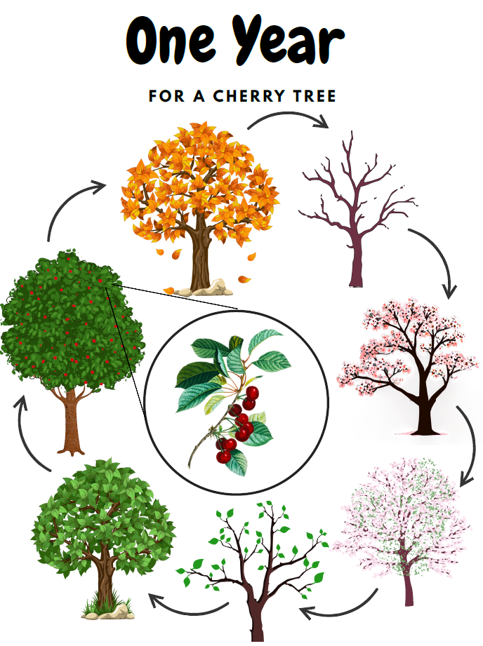
🐟 Life Cycle of a Salmon – Lesson Summary
🎯 Learning Goals
Students will:
- Identify the stages of a salmon’s life cycle
- Describe how salmon change as they grow
- Sequence the stages in order
- Understand that salmon migrate (travel) between rivers and the ocean
🧠 Key Vocabulary
Life cycle, egg, alevin, fry, smolt, adult salmon, migration
🐟 Salmon Life Cycle Stages
- Egg – Salmon eggs are laid in freshwater rivers and streams. They are protected in gravel nests.
- Alevin – The eggs hatch into alevins, which stay hidden in the gravel and live off a yolk sac for food.
- Fry – Young salmon leave the gravel, begin swimming, and start feeding on small organisms.
- Smolt – As they grow, salmon develop the ability to live in saltwater and begin their journey to the ocean.
- Adult Salmon – Fully grown salmon live in the ocean.
- Spawn - When it is time to reproduce, they migrate back to their birthplace in freshwater to lay eggs and start the cycle again.
🚀 Lesson Activities
- Introduction: Ask students if they have seen salmon or heard about salmon swimming upstream; show pictures or a short video.
- Teaching: Explain each stage using visuals or diagrams.
- Guided Practice: Students arrange the life cycle stages in order.
- Independent Work: Students draw, label, or complete a worksheet about the stages.
🔄 Closure
Review the stages and highlight the salmon’s journey between river and ocean. Emphasize the idea of migration.
🌟 Extensions & Supports
- Discuss salmon in local ecosystems (especially in BC)
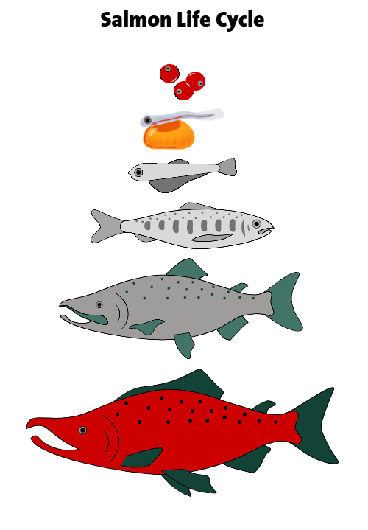
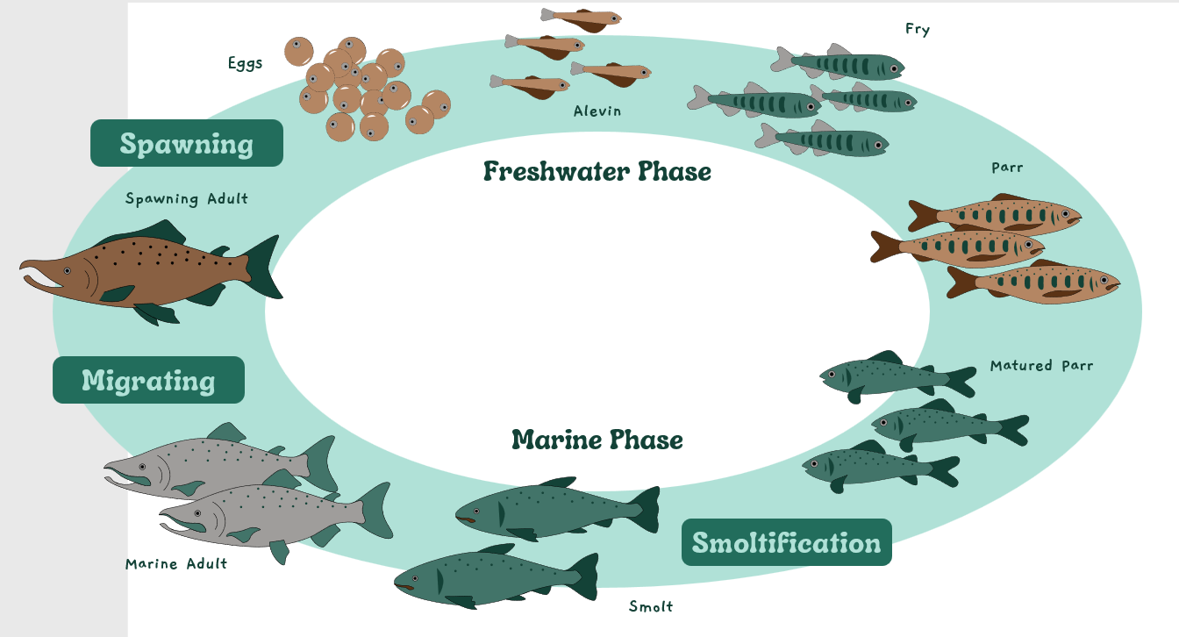

👶 Life Stages of a Human – Lesson Summary
🎯 Learning Goals
Students will:
- Identify the stages of human life
- Describe how people grow and change
- Sequence the stages in order
- Understand that all living things grow and develop over time
🧠 Key Vocabulary
Life cycle, baby, child, teenager, adult, growth, development
👶 Human Life Stages
- Baby (Infant) – Babies are born very small and need lots of care. They learn basic skills like eating, crawling, and walking.
- Child – Children grow taller and stronger. They learn to talk, read, play, and go to school.
- Teenager (Adolescent) – Teenagers grow quickly and become more independent. Their bodies and feelings change as they develop.
- Adult – Adults are fully grown. They can work, take care of others, and make their own decisions.
(Optional extension: Some lessons may include senior/elder stage for older learners.)
🚀 Lesson Activities
- Introduction: Ask students how they have changed since they were babies
- Teaching: Explain each life stage using visuals or examples.
- Guided Practice: Students arrange life stage pictures in order.
- Independent Work: Students draw themselves at different ages or complete a labeling worksheet.
🔄 Closure
Review the stages and discuss how everyone grows and changes over time. Reinforce that all people have a life cycle.
🌟 Extensions & Supports
- Create a personal timeline (baby to present)
- Compare human life stages with other animals
