**Oversharing: Think Before You Post**



**Remember the golden rule**



**Don’t brag**

**Avoid TMI**

**Think about the reader**

**Keep relationship details to yourself**

**Don’t be cryptic**

**Quit complaining**

**Curate your photos**

**Change your settings**

**Post smart**

**OVERSHARING** © 2014 Visit[**www.commonsense.org**](http://www.commonsense.org) to learn more.

I might show you where I’m going,

But I think before I’m posting.

All my pictures have been chosen,

Not just posting whatever, whatever, whatever



**OVERSHARING:**

**THINK BEFORE YOU POST**

**Social media can be complicated**. Here’s some things to help you post smart. Flocab, let’s go.

I might show you where I’m going,

But I think before I’m posting.

All my pictures have been chosen,

**Not just posting whatever, whatever, whatever**... (x2)

So many sites to post pics and post comments,

And make your friends say “holy smokes” like Robin.

Your posts live forever, that’s a long time,

So don’t overshare when you go online.

Yeah — **Your digital footprint will stick with ya**,

So stop and think before you post that picture

Or message... Flocab let’s go,

The Top 10 Things to Think About Before You Post.

**Ask yourself would you say it in real life**,

If the answer’s no, don’t post it online.

And if you wouldn’t want it said about you,

Don’t post it about someone else, that’s the golden rule.

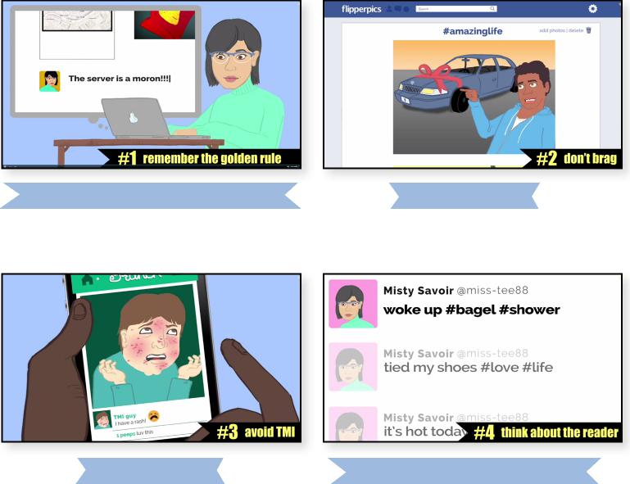

**#1 Remember the golden rule**

**#3 Avoid TMI #4 Think about the reader**

**#2 Don’t brag**



**#1**

**Are your posts vain and narcissistic?** About your perfect life, all designed to elicit

Jealousy and envy in the people who read it?

If so, don’t post that brag, delete it.

**That’s TMI folks**,

“I have a rash!” Well, I didn’t want to know.



**#2**

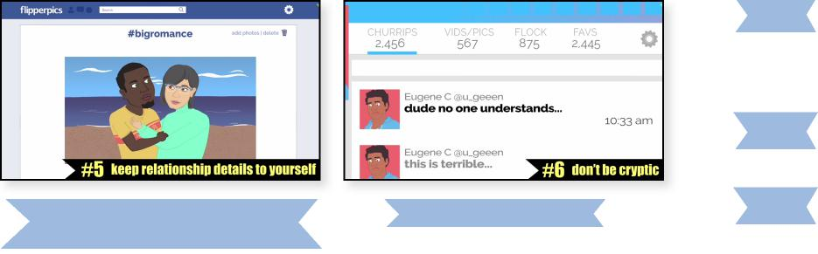

**#3**

**Are you posting every detail of your life**,

Who in their right mind is gonna find that nice?

“Woke up #bagel #shower,”

And 20 more posts in the next half hour.

Think about the reader when you’re sharing,

Edit your posts, and your friends will keep caring.

**A bit like 4, here’s what’s else,**

**Keep your relationship details to yourself**.

You don’t need to post every hug and sunset,

That might make your single friends feel upset.

A moment still has meaning even if you don’t post it,

Know this, now let me get back and focus.

**the “Cryptic Cliffhanger,” man**,

Like: “Dude no one understands.”

It’s a little desperate, begging for attention,

Just be up front off the bat with what you mention.

**Are your posts all complaining?**

You really need pity just because it’s raining?

**Curate your photos like a museum**,

Don’t post pics you wouldn’t want your grandma seeing.

Goes double for anything risky or risque,

That could affect your future in a big way.

And that’s doubly doubly true,

If it’s a photo of a friend and not just you.

**Check your privacy settings, I mean it**, Want creeps or future employers to read it?

You really want your InstaFaceTweets,

Like concrete — I mean all over the the streets?

**#4**

**#6 Don’t be cryptic**

**#5 Keep relationship details to yourself**

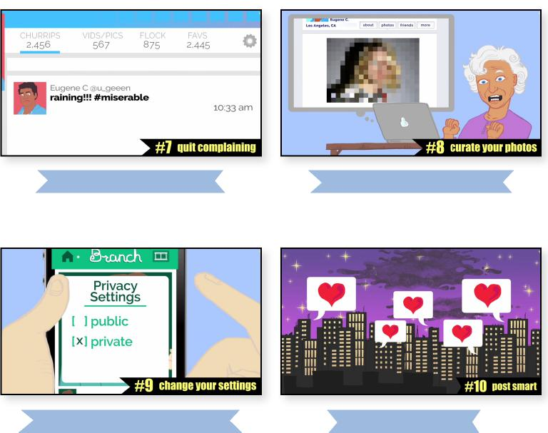

**#7 Quit complaining #8 Curate your photos**

**#9 Change your settings #10 Post smart**



**#5**



**#6**



**#7**

**#8**



**#9**

**Brought to you by**



**Post smart, OK?**

And spread love, that’s the Brooklyn way.



**#10**