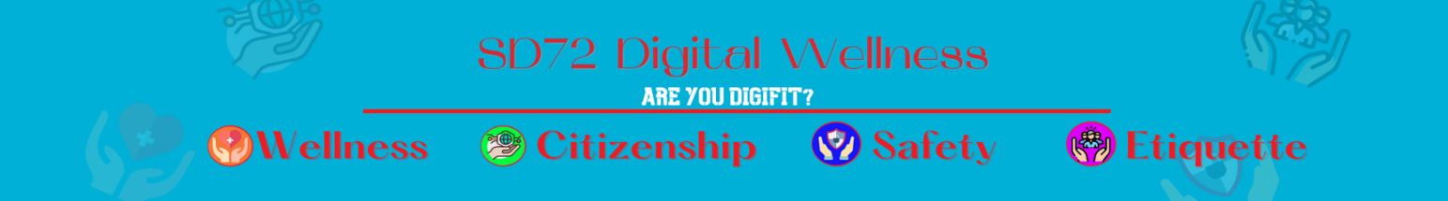
Understanding Copyright - Definitions
Copyright  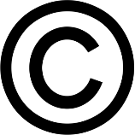 | Copyright is the exclusive legal right to produce, reproduce, publish or perform an original literary, artistic, dramatic or musical work.  (It is usually the creator BUT sometimes it’s the employer that is the copyright owner (film studio). | List some SPECIFIC things that would be copyrighted.
Public Domain  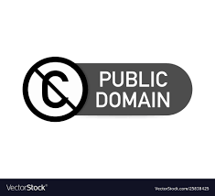 | Works that are not protected by copyright. You are free to use them in any way you choose - no restrictions on copying and adapting, no need to seek permission, and no uncertainty about your rights as a user. | List some SPECIFIC things that would be found in the public domain.
Fair Dealing  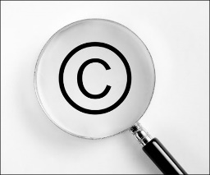 | The use of material from a copyright protected work (literature, musical scores, audiovisual works, etc.) without permission when certain conditions are met. People can use fair dealing for research, private study, education, parody, satire, criticism, review, and news reporting. | List some SPECIFIC scenarios that would use the fair dealing guidelines.
Creative Commons  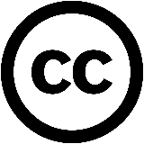 | A type of license that enable the free distribution of an otherwise copyrighted "work". A CC license is used when an author wants to give other people the right to share, use, and build upon a work that the author has created. | List some SPECIFIC reasons why someone would want to share THEIR OWN work with a CC license.

