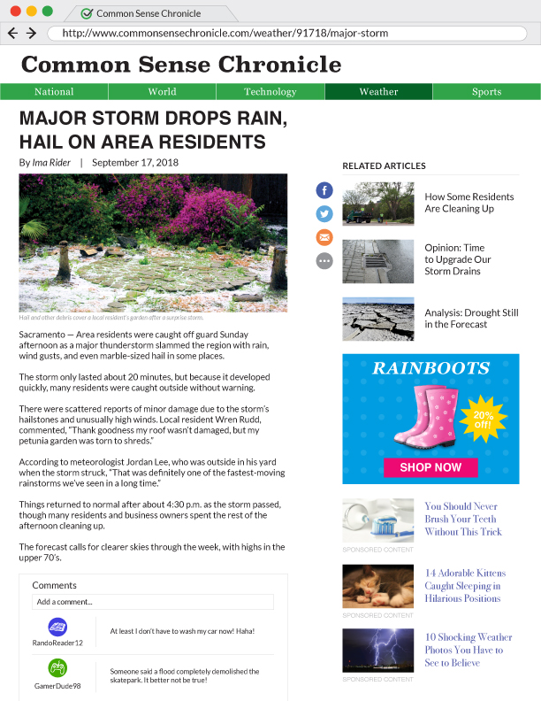

Directions
Work with your group to cut out each of the labels below and paste them onto your example article. Make sure that each part of the online news story is labeled correctly. Also, do your best to paste the labels so that they don't completely cover any part of the example article.

Headline

Byline

URL (address bar)

Section title

Image (or video)

Date

Related Articles

Advertisement

Sponsored Content

Comments

