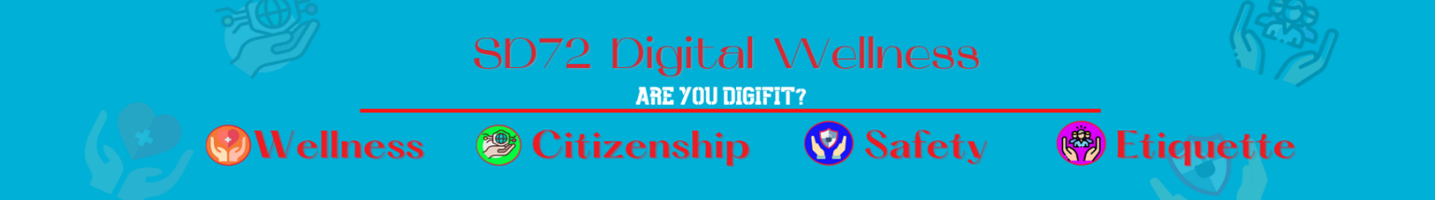

Stand Up Sit Down
Fake Highlight Reel vs Behind the Scenes Posting

- your new dirt bike/skate board or something else you might have received
- surfing on vacation (or other vacation activities
- picture of meal you’re about to eat
- doing chores
- outdoor activity
- post of boyfriend/girlfriend
- filtered selfie picture
- meme/post of struggles that might have occurred
- family gathering at Christmas, birthday or any other type of occasion
- cute picture of pet
- picture of self on bad hairday
- post of montage of scoring a goal, completing a successful “jump” (bike, ski, skateboard, etc), filtered selfies with hair and makeup perfect
- post of highlight of event (dance, sporting, birthday, vacation, etc)
- post of spending some quality time with friends or family

