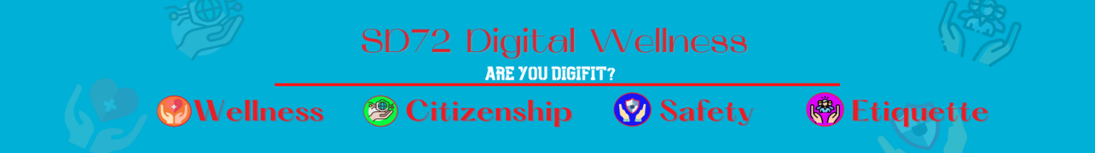

Okay No Way Copyright Permission
Game Scenarios
- Manny has to write a science report about where his local water comes from. He finds a paragraph on a website that is just right for his report. Manny copies it in his own handwriting and changes a couple of words to make it sound like something he would say. Is this "OK" or "no way"?
- Susie wants to use a picture she found online on her Facebook account. She found it just in a general internet search AND she doesn’t see specifically that there is copyright protection on it. Is this “OK” or “no way”?
- Jack has a Netflix account. He heard from a friend that one of his favourite movies has just been added and he is totally excited to watch it. He invites a whole bunch of his friends over to his house to watch it. Is this “OK” or “no way”?
- Jack likes this movie so much that he asked his teacher to show it to all of the students in the class at school. Is this “OK” or “no way”?
- Ian is doing a media project for his teacher at school. He is demonstrating how buyllying hurts people and he found a clip online that he only needs FIVE seconds of a THREE minute video that would be perfect as part of his video. Is this “OK” or “no way”?
- You drew a picture at school and your teacher uploaded to the internet with your permission. However, the following week you see your picture on someone else’s website. Is this “OK” or “no way”?
- You found your favourite song on YouTube. You want to be able to play it ALL the time NOT just when you are connected to the internet so you are looking at ways to download it to your local device. Is this “OK” or “no way”?
- You are creating a poster at school. You need to include icons to accompany words you are including. You found a creative commons website that allows you to use these icons for free as long as you give the artist credit. However, you didn’t give them credit. Is this “OK” or “no way”?

