Lesson Template
Unit Topic: Lesson Question:
 | Connect | Process | Transform
Activity
All
Goal:
Modification
Goal:
Some  Goal: |  | 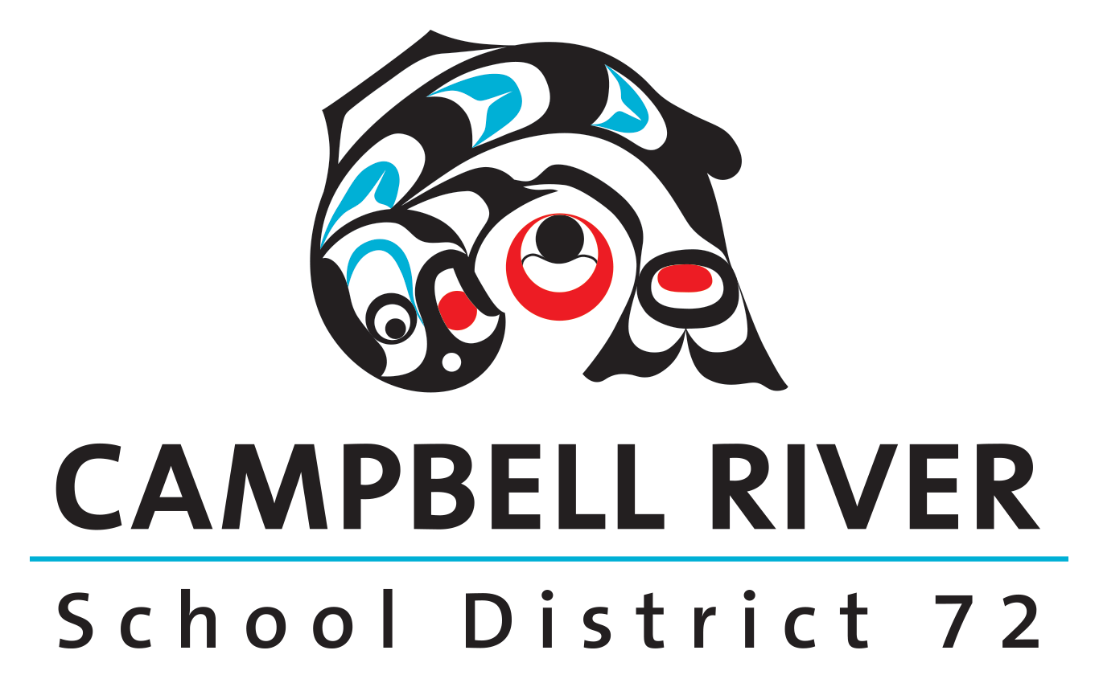
Few
Goal:

