How to Customize File Sharing Settings
The default sharing settings are now more restricted to better protect your data by default. However, you are still able to change your file sharing settings manually.

Locate the file that you would like to share. Make sure that is save to your OneDrive so that you are able to share it. The easiest way to find your OneDrive is to look for the blue cloud on the left side of you file explorer.
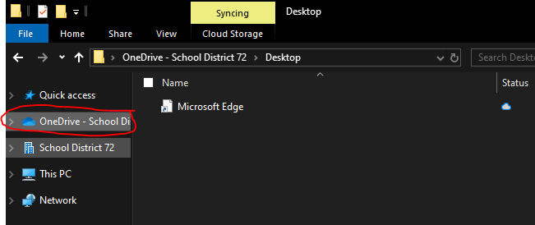



Move the file(s) you would like to share into your OneDrive. If there are multiple files
you would like to share, create a new folder by right clicking, selecting “new” and then
“folder”. Give the folder a descriptive name. Now move your files into this folder.
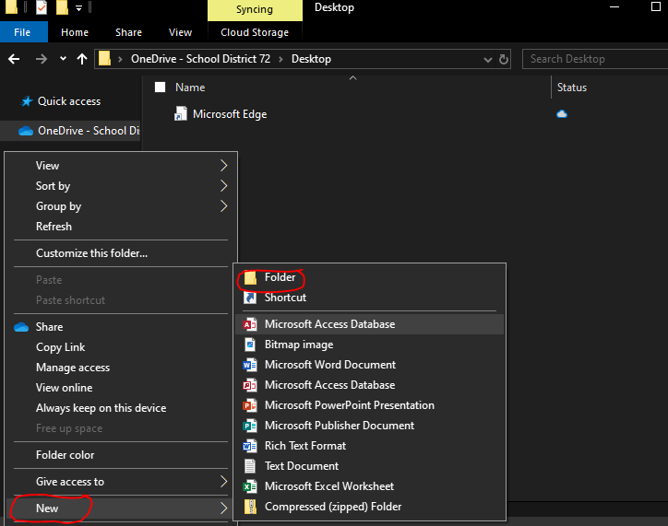

• Right Click on the file or folder you’d like to share.
• Select “Share” from the list.
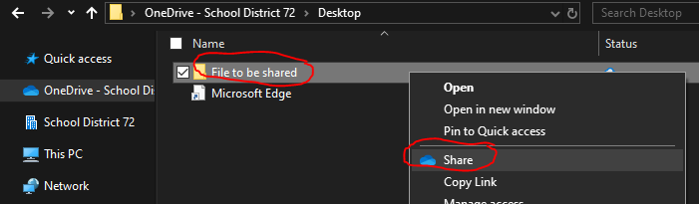

• You are now presented with a popup window. Click on the settings cog button.
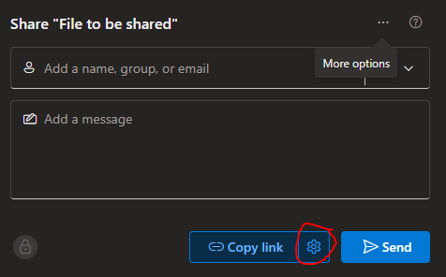

Look at the following settings.
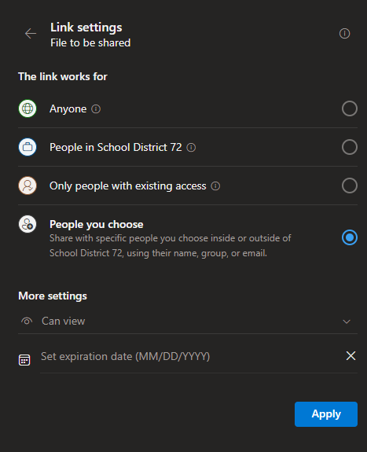
Set expiration dates:
- If you need to provide long-term access to a file, extend the expiration date as needed.
Once you are satisfied with the settings, confirm them with “Apply”
Adjust permissions:
- By default, links are set to “can view”. If you want the recipient to edit the document, change the setting to “can edit”.

Customize who can access the link:
- Select “People in SD72” to share with staff within the district.
- Choose “Anyone” if you need to share the link with parents or individuals outside the district.

Now either type in the names of those you Or copy the link to share

like to share with
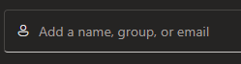
Changing settings when attaching files to email
You can also share files through Outlook. If you drag a file onto an email draft, you can attach a copy of the file by dropping it on the right side of the page. Alternatively, you can upload the file to OneDrive and share the link by dropping it on the left side of the page (this option is better for large files or collaboration).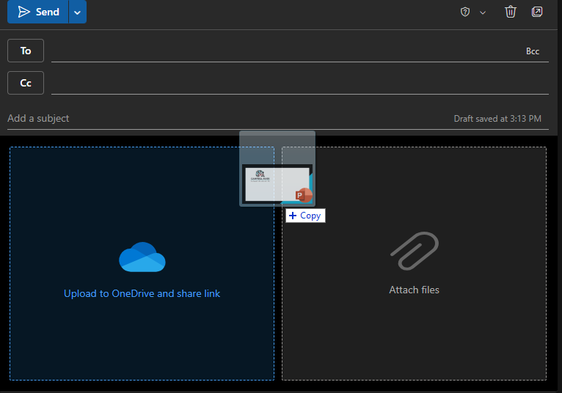
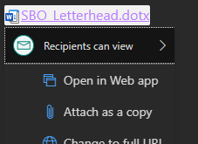
If you share a file via OneDrive, you can adjust the sharing settings by clicking on the link and selecting “Recipients can view”. Follow the steps above to modify view or editing access, control who can open the link, and set the expiry date.

